Alan Himes

CP221 ORACLE SQL QUIZ #3 FINAL
Upload to Blackboard

- Create these 2 tables in the ERD and add the constraints in ERD
You can use the spreadsheets in the FINAL folder however you want:
You can import them as Tables then fix them up in the PENCIL
OR
You can create the Create Table Code 1st then Import the data into yr. tables

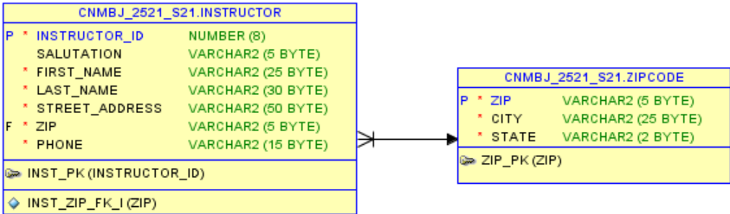

- Add a FK constraint in Sections to talk to the INSTRUCTOR table.

Screen print the SQL tab showing the FK constraint was added.

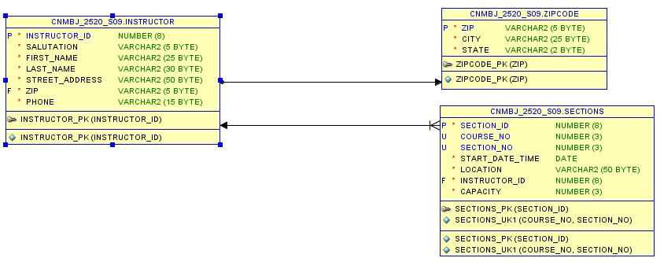

- Please help, something is wrong with my Create table syntax, please fix it
(Hint: There are at least 5 errors) Show corrected code:

Create Table Emp_Clubs
(Club_id number(4),
Club_Name varcha2(10)
Location varchar2(15) Constraint empclub_loc_NN Not Null,
Contact_Emp number(6) Constraint empclub_loc_NN Not Null,
Constraint Empclub_id_PK Primary Key,
Constraint Empclub_name_NN Not Null,
);

Create Table Emp_Clubs
(Club_id number(4),
Club_Name varchar2(10) Constraint Empclub_name_NN Not Null,
Location varchar2(15) Constraint empclub_loc_NN Not Null,
Contact_Emp number(6) Constraint empclub_contact_NN Not Null,
Constraint Empclub_id_PK Primary Key (club_id)
);

- ADD this column to the EMPLOYEE_CLUBS table you created (USE ALTER table)

COLUMN: DAYS VARCHAR2(4)

alter table emp_clubs add (days varchar2(4));

- Modify the EMP_CLUBS table to change a column (USE ALTER table )
Make the column: CLUB_NAME to be VARCHAR2(20)

alter table emp_clubs modify (club_name varchar(20));

- Add a FOREIGN KEY constraint called EMP_CLUB_EMP_FK: (USE ALTER table)
Use Contact_emp as the FK that will tie back to the EMPLOYEES.employee_id

alter table emp_clubs modify (constraint EMP_CLUB_EMP_FK foreign key (contact_emp) references employees(employee_id));

- Add these 3 records to your EMP_CLUBS table. USING an explicit INSERT Commands
(name the columns, before the Values clause) Make the insert permanent.

CLUB_ID CLUB_NAME LOCATION CONTACT_EMP DAYS
-------------------- ------------------------------------------------ ----------------------
500 IT Club E101 101 TUE
505 Gamers E103 105 THU
510 Hackers E103 105 FRI

insert into emp_clubs (club_id, club_name, location, contact_emp, days) values (500, 'IT_CLUB', 'E101', 101, 'TUE');
insert into emp_clubs (club_id, club_name, location, contact_emp, days) values (505, 'GAMERS', 'E103', 105, 'THU');
insert into emp_clubs (club_id, club_name, location, contact_emp, days) values (510, 'HACKERS', 'E103', 105, 'FRI');

- Update the record CLUBID=500 you just added to change the:Days from TUE to WED Make the update permanent. USE an UPDATE command.
update emp_clubs set days = 'WED' where club_id = 500;

- Delete the record CLUBID=510 Hackers. Make the delete permanent.

delete emp_clubs where club_id = 510;
commit;

- Create a view called Emp_AnnSal60_view. Make the view so no DML can be attempted on it.
That combines the employees, departments, jobs tables together and shows:
Employee_id, Concatenate first_name and Last_name into a column called Name, job_title, department_name, compute a field
called Annual_Salary (salary *12) Format Annual_salary with $999,999.99
SHOW only EMPLOYEES in department_id = 60

Give these column aliases: Employee_ID ID
Job_title JOB
DEPARTMENT_NAME DEPARTMENT

create or replace force view Emp_AnnSal60_view as select e.employee_id, e.first_name || ' ' || e.last_name name, j.job_title, d.department_name, to_char((salary * 12), '$999,999.99') annual_salary from employees e, jobs j, departments d where e.department_id = d.department_id and e.job_id = j.job_id;

- Create a Synonym for the EMP_CLUBS table called EClub and issue a select
statement using the synonym. Show both commands.

create synonym eclub for emp_clubs;
select * from eclub;

- Create a sequence named EMPCLUB_ID_SEQ .
Start at 550 INCREMENT BY 5 max value 5000. Use NOCYCLE and NOCACHE

create sequence empclub_id_seq start with 550 increment by 5 maxvalue 5000 nocycle nocache;

- Insert the 2 records below into your EMPLOYEE_CLUBS and use your sequence in the values clause for CLUB_ID. (use an explicit insert stmt)

CLUB_ID CLUB_NAME LOCATION CONTACT_EMP DAYS
---------------------- ------------------------------------------------ ---------------------- ------------
Use sequence name.nextval Football E101 105 MON
Use sequence name.nextval Music E103 107 TUE
insert into emp_clubs (club_id, club_name, location, contact_emp, days) values (empclub_id_seq.nextval, 'Football', 'E101', 105, 'MON');
insert into emp_clubs (club_id, club_name, location, contact_emp, days) values (empclub_id_seq.nextval, 'Music', 'E103', 107, 'TUE');

That’s all FOLKS thanks for being in the class and have a Restful Break !!

Thanks!!

